**Name: Stuti Sehgal**

**Sap ID: 500107063**

**Batch: 2**

**Lab Exercise 12– Creating an AWS RDS Instance in Terraform**

**Objective:**

Learn how to use Terraform to create an AWS RDS instance.

**Prerequisites:**

* Terraform installed on your machine.
* AWS CLI configured with the necessary credentials.

**Steps:**

1. **Create a Terraform Directory:**

**mkdir terraform-rds**

**cd terraform-rds**

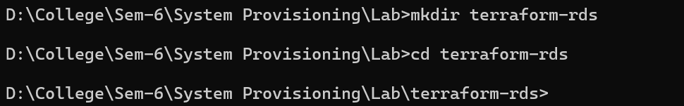

1. **Create Terraform Configuration Files:**

Create a file named main.tf:

**# main.tf**

**provider "aws" {**

**region = "us-east-1"**

**}**

**resource "aws_db_instance" "My-RDS" {**

**allocated_storage = 10**

**db_name = "upesdb"**

**engine = "mysql"**

**engine_version = "5.7"**

**instance_class = "db.t2.micro"**

**username = "admin"**

**password = "Hitesh111"**

**parameter_group_name = "default.mysql5.7"**

**skip_final_snapshot = true**

**}**

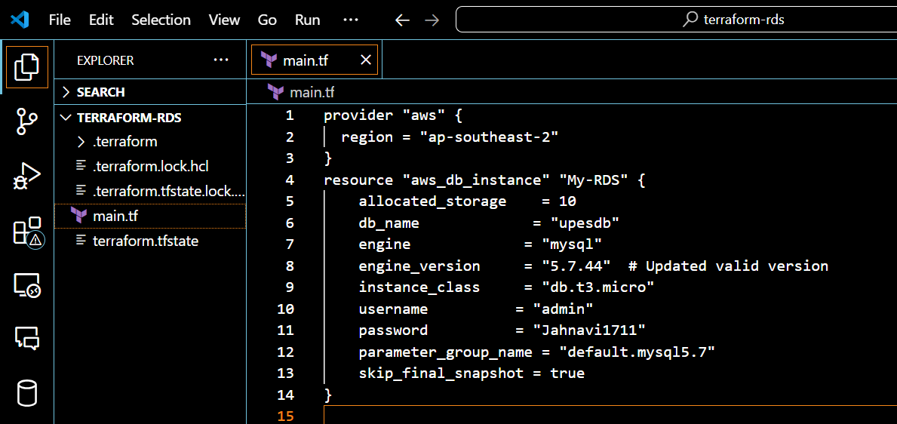

* Replace "YourPassword123" with a secure password and "your-security-group-id" with your actual security group ID.
* In this configuration, we define an AWS RDS instance with specific settings, such as engine type, instance class, and security group.

1. **Initialize and Apply:**

* Run the following Terraform commands to initialize and apply the configuration:

**terraform init**

**terraform apply**

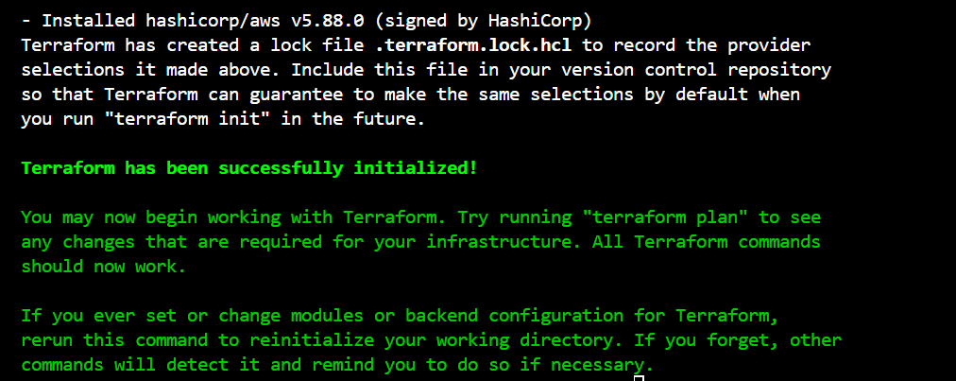

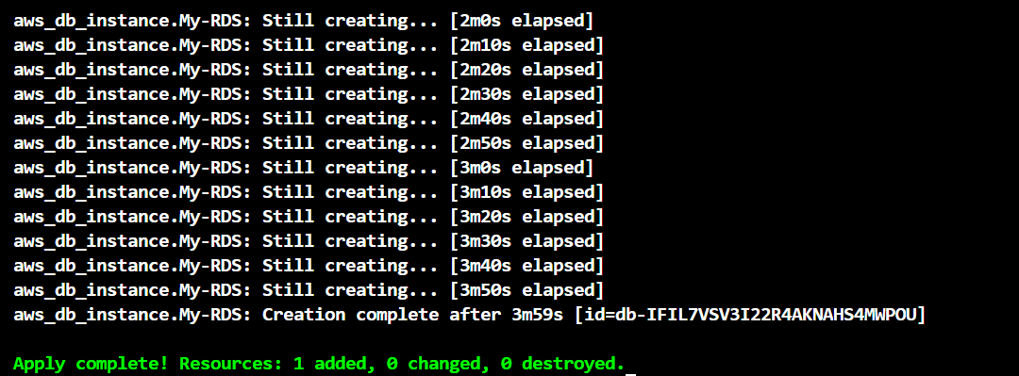

* Terraform will prompt you to confirm the creation of the RDS instance. Type yes and press Enter.

1. **Verify RDS Instance in AWS Console:**

* Log in to the AWS Management Console and navigate to the RDS service.
* Verify that the specified RDS instance with the specified settings has been created.

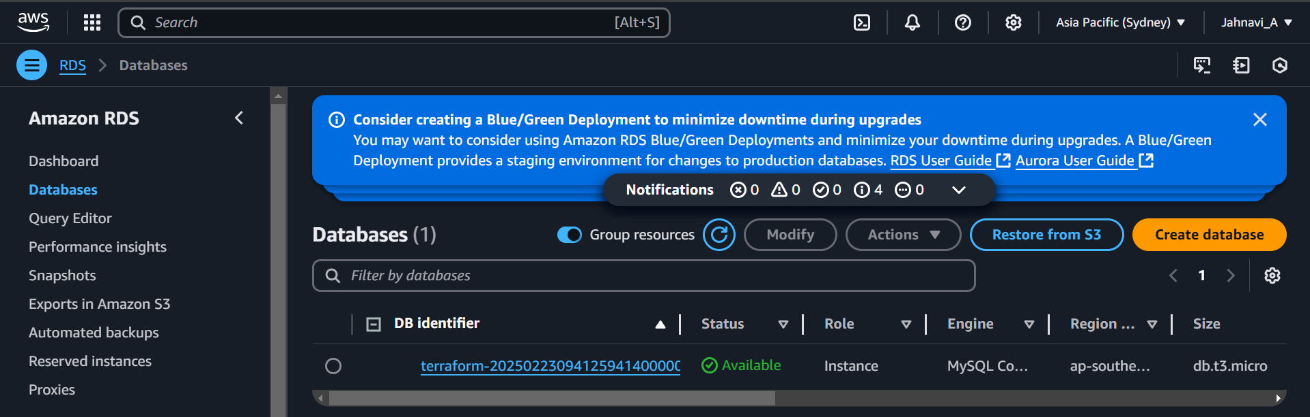

1. **Update RDS Configuration:**

* If you want to modify the RDS instance configuration, update the main.tf file with the desired changes.
* Rerun the terraform apply command to apply the changes:

**terraform apply**

1. **Clean Up:**

After testing, you can clean up the RDS instance:

**terraform destroy**

Confirm the destruction by typing yes.

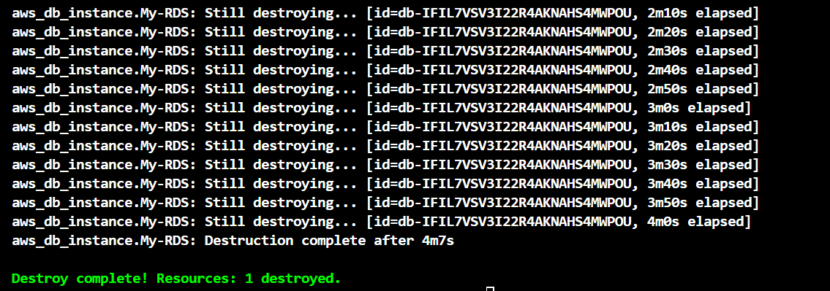

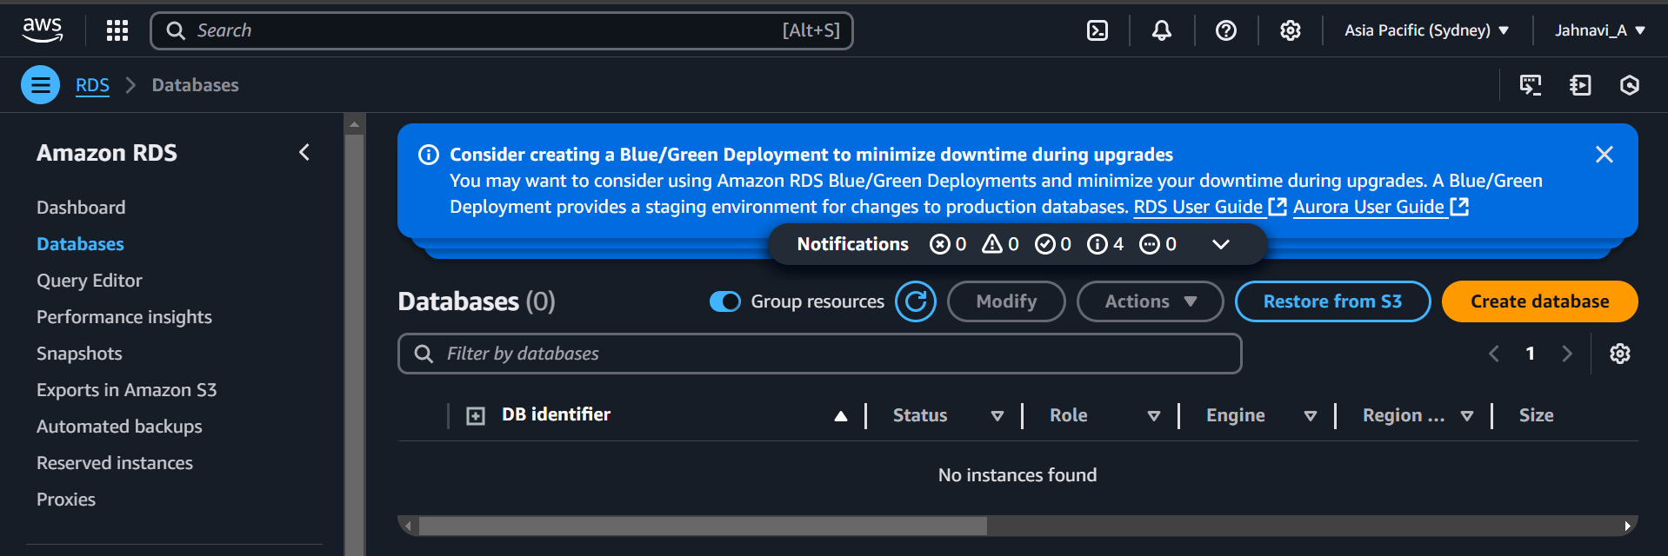

1. **Conclusion:**

This lab exercise demonstrates how to use Terraform to create an AWS RDS instance. You learned how to define RDS settings, initialize and apply the Terraform configuration, and verify the creation of the RDS instance in the AWS Management Console. Experiment with different RDS settings in the main.tf file to observe how